SIMATS ENGINEERING ASSESSMENT TOOL 1

COURSE NAME: Database Management Systems
COURSE CODE: CSA0508

COURSE OUTCOME COVERED

CO2: Apply the relational model, relational algebra, SQL query structures, and views to solve database querying and data manipulation problems. (BL3, BL6)

Activity Tool : Analytical Problem Solving (High)
Assessment Tool Weightage: 35%

Dr.G.Ayyappan

QUESTIONS
Total Marks: 50
Q.No | Question | Bloom's  Level | Marks
1 | Apply relational algebra operations (σ, π, ∪, -, ×, ⋈) on the given Employee and Department relations to retrieve required records. | BL3 – Apply | 5
2 | Write SQL DDL statements to create  STUDENT(SID, Name, DOB, DeptID) and DEPARTMENT(DeptID, DeptName) tables with all appropriate constraints. | BL3 – Apply | 5
3 | Formulate SQL queries using GROUP BY,  HAVING, and aggregate functions (COUNT, | BL3 – Apply | 5
 | SUM, AVG, MAX, MIN) on a given Sales dataset.
4 | Write a correlated sub-query to find employees earning more than the average salary of their own department. | BL3 – Apply | 5
5 | Apply all types of JOIN operations (INNER,  LEFT OUTER, RIGHT OUTER, FULL  OUTER, CROSS) on Employee and Project tables. | BL3 – Apply | 5
6 | Create a view 'DeptSalaryView' that displays department name, total employees, and average salary. Write a query on this view. | BL6 –  Create | 5
7 | Construct a relational algebra expression for the following: Find names of students who are enrolled in all courses offered. | BL6 –  Create | 5
8 | Write SQL DML statements (INSERT, UPDATE, DELETE) with integrity constraint enforcement for a given scenario. | BL3 – Apply | 5
9 | Apply tuple relational calculus to express a query: Find all employees who work in the 'IT' department and earn more than 50000. | BL3 – Apply | 5
10 | Design a relational schema for an Airline Reservation System and write 5 SQL queries demonstrating joins, sub-queries, and views. | BL6 –  Create | 5

Code of Conduct:

I APSAL HAMEED.J (192524286) certify that this submission is my original work and that I have adhered to the guidelines specified for this assessment.
I understand that any violation of academic integrity rules will result in disciplinary action.

Signature of the student:

RUBRICS FOR CALCULATION:

 |  | Numerical Problems
Criteria | Weighta ge | Level 4  (Exemplary  ) | Level 3  (Proficien  t) | Level 2  (Developin  g) | Level 1  (Beginnin  g)
Problem  Understand ing | 20% | Clearly interprets problem,  identifies all  parameters and  requirements accurately | Understan ds  problem  with minor gaps | Partial understandi ng; misses key elements | Misinterpr ets or  unable to  understand problem
Method  Selection | 20% | Selects most appropriate  method/form ula with  strong justification | Selects correct  method  with minor errors | Inappropria  te or  partially correct method | Unable to select  method
Solution Process | 25% | Logical, systematic  steps with correct  approach throughout | Mostly correct  steps with minor mistakes | Disorganize d steps;  multiple errors | No clear process
Accuracy  of  Calculation | 20% | All calculations accurate; | Minor calculation errors | Frequent errors; incorrect | No valid calculation  s
 |  | correct final answer |  | final  answer
Interpretati on of  Results | 15% | Clearly interprets  results with units and  engineering relevance | Basic interpretati  on with minor omissions | Limited or unclear  interpretati on | No  interpretati on

- Relational Algebra Operations (σ, π, ∪, −, ×, ⋈)
Relational Algebra is a procedural query language used to retrieve data from relational databases. It consists of several operations that manipulate relations (tables) and produce new relations as results.
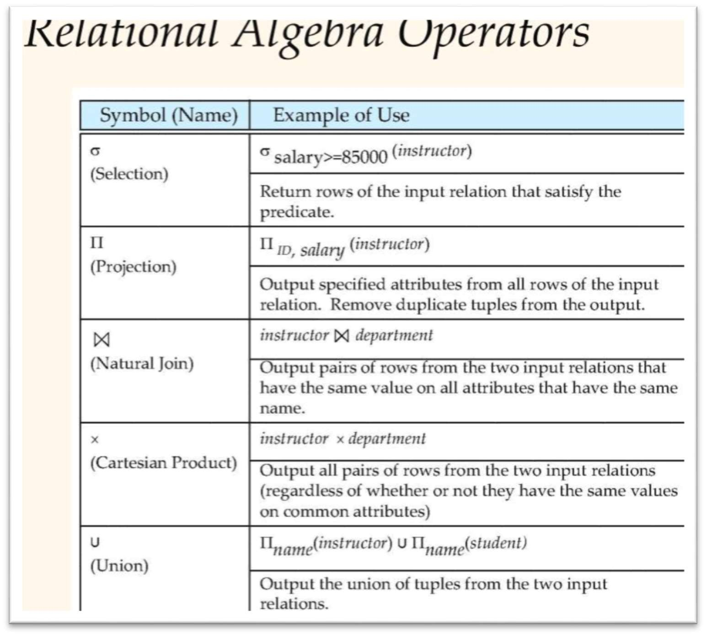

  - Selection (σ): The selection operation retrieves rows (tuples) from a relation that satisfy a specified condition. For example, selecting employees whose salary is greater than ₹50,000.
  - Projection (π): Projection retrieves specific columns (attributes) from a relation while removing duplicate values. For example, displaying only employee names.
  - Union (∪): The union operation combines the tuples from two compatible relations and removes duplicate tuples. Both relations must have the same number of attributes and compatible data types.
  - Difference (−): Difference returns tuples that are present in one relation but not in another. It is useful for finding records that do not satisfy certain conditions.
  - Cartesian Product (×): The Cartesian product combines every tuple of one relation with every tuple of another relation, producing all possible combinations.
  - Join (⋈): Join combines tuples from two relations based on a common attribute. It is commonly used to retrieve related information stored in different tables, such as employee details along with department names.

- SQL DDL Statements
Data Definition Language (DDL) is used to define and manage the structure of database objects such as tables, indexes, and constraints.
The STUDENT table contains the student ID, student name, date of birth, and department ID. The DEPARTMENT table contains the department ID and department name.
Appropriate constraints include:
  - 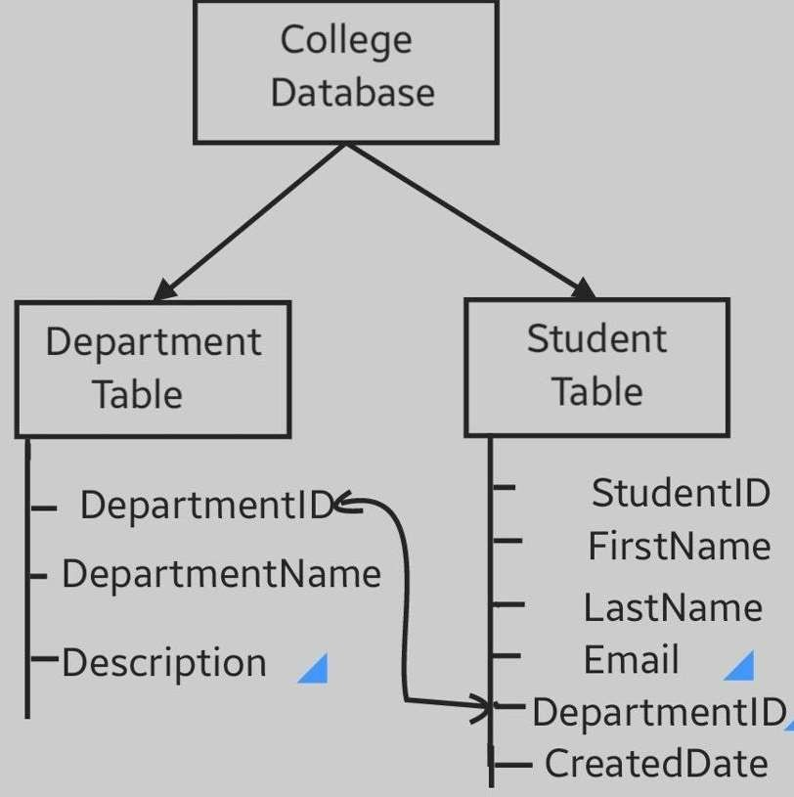
  - PRIMARY KEY: Ensures each record is unique.
  - NOT NULL: Prevents NULL values.
  - UNIQUE: Prevents duplicate values.
  - FOREIGN KEY: Maintains referential integrity by linking the STUDENT table to the DEPARTMENT table.
These constraints improve data integrity and consistency in the database.
- GROUP BY, HAVING, and Aggregate Functions
Aggregate functions perform calculations on multiple rows and return a single value.
  - COUNT(): Returns the total number of records.
  - SUM(): Calculates the total of a numeric column.
  - AVG(): Finds the average value.
  - MAX(): Returns the highest value.
  - MIN(): Returns the lowest value.
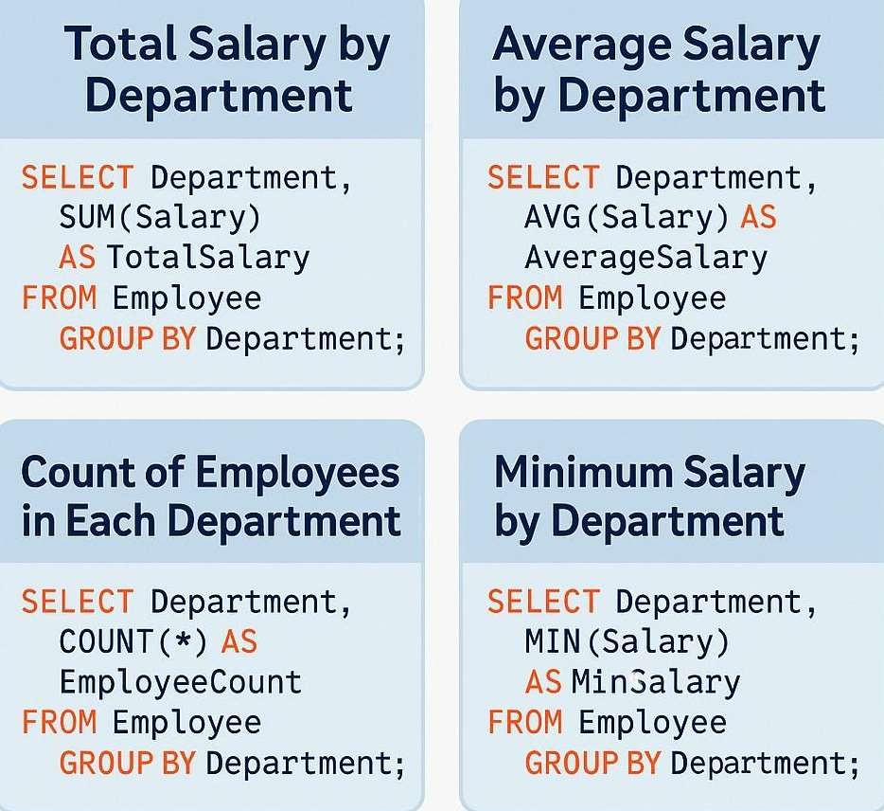
The GROUP BY clause groups rows having the same values into summary rows. It is generally used with aggregate functions.
The HAVING clause filters grouped records after the GROUP BY operation.
Unlike the WHERE clause, HAVING is used to specify conditions on groups.
For example, in a Sales table, GROUP BY can calculate the total sales for each product, while HAVING can display only those products whose total sales exceed a specified amount.

- Correlated Sub-query
A correlated sub-query is a sub-query that depends on the outer query for its execution. It is executed once for every row processed by the outer query.
For example, to find employees earning more than the average salary of their own department, the sub-query calculates the average salary for each department and compares it with the salary of each employee.
Correlated sub-queries are commonly used for row-by-row comparisons and complex filtering conditions.
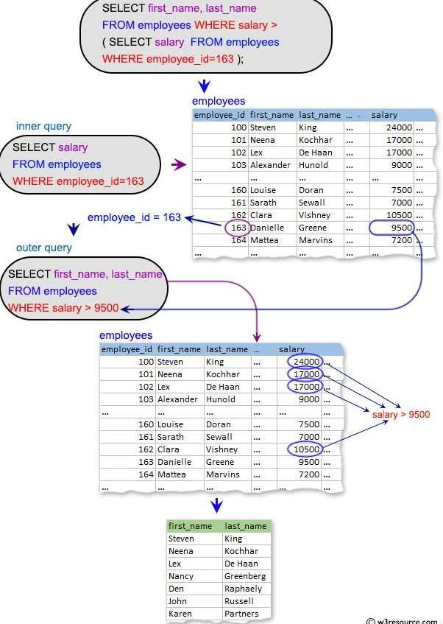

5. Types of JOIN Operations
A JOIN operation combines rows from two or more tables based on a related column.

Inner Join
Returns only the matching records from both tables. Records without matching values are excluded.

Left Outer Join
Returns all records from the left table and only the matching records from the right table. If no match exists, NULL values are displayed for the right table.

Right Outer Join
Returns all records from the right table and matching records from the left table. Unmatched rows from the left table contain NULL values.

Full Outer Join
Returns all matching and non-matching records from both tables. NULL values are displayed wherever no matching record exists.

Cross Join
Returns the Cartesian product of both tables by combining every row of one table with every row of the other table.
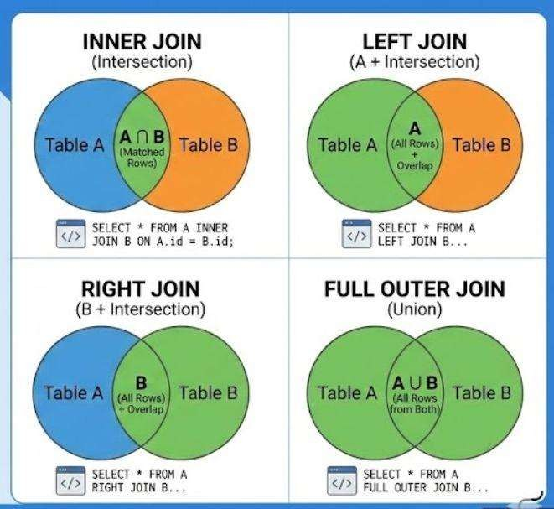

6. View – DeptSalaryView
A View is a virtual table created using a SELECT statement. It does not store data physically but displays data from one or more tables.
The view DeptSalaryView contains:
- Department Name
- Total Number of Employees
- Average Salary
Views provide the following advantages:
- Improve security by restricting access to specific columns.
- Simplify complex SQL queries.
- Improve code reusability.
- Provide data abstraction.
Queries can be executed on the view just like a normal table.
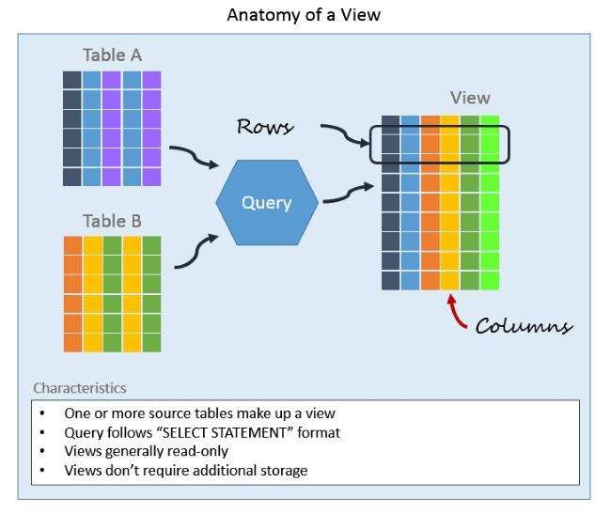

- Relational Algebra Expression – Students Enrolled in All Courses
To find students enrolled in all available courses, the Division (÷) operator is used.
The Division operation returns those students who are associated with every course offered by the institution.
This query is useful in situations where "all" conditions need to be satisfied, such as finding students who completed every compulsory course.
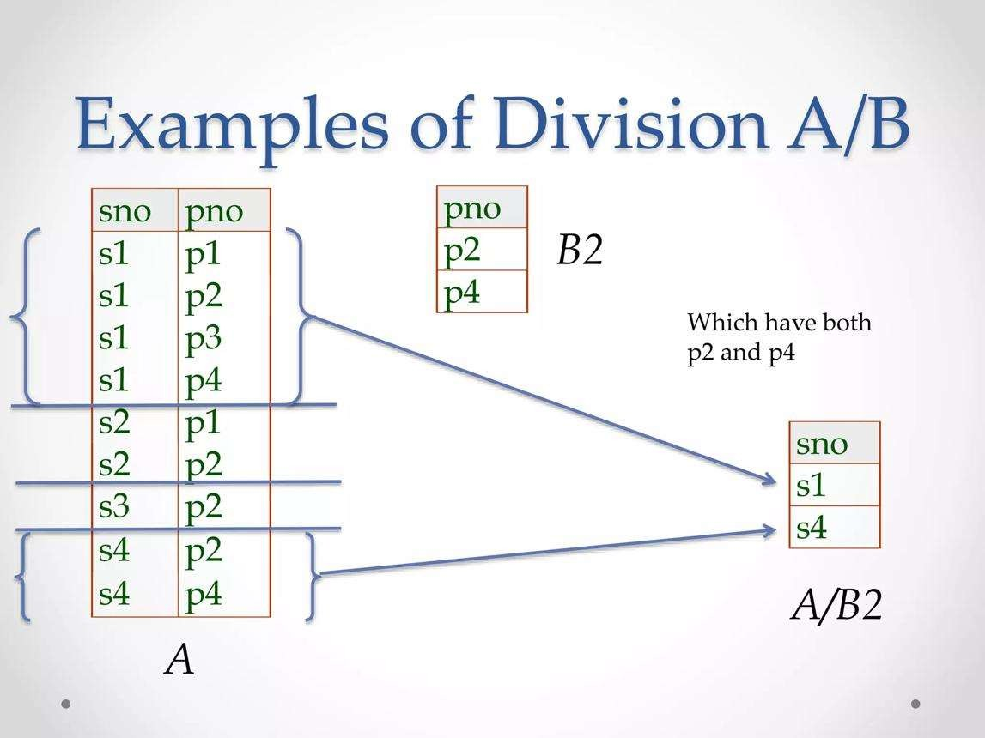

- SQL DML Statements
Data Manipulation Language (DML) is used to manipulate data stored in database tables.
The three major DML statements are:
INSERT
Adds new records into a table.
UPDATE
Modifies existing records in a table.

DELETE
Removes records from a table.
While performing DML operations, integrity constraints such as Primary Key, Foreign Key, Unique, and Not Null constraints ensure that the data remains valid and consistent.
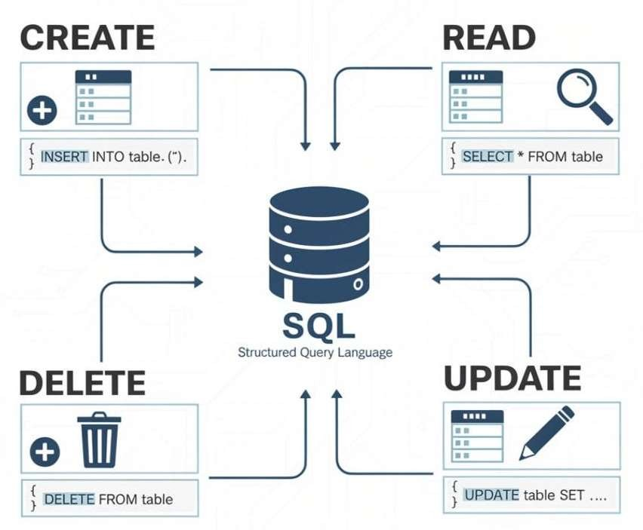

- Tuple Relational Calculus (TRC)
Tuple Relational Calculus is a non-procedural query language. It specifies what data is required rather than how to retrieve it.
In Tuple Relational Calculus, variables represent tuples, and queries are expressed using logical predicates.
To find employees working in the IT department and earning more than ₹50,000, the query specifies conditions that the employee must satisfy without describing the retrieval procedure.
TRC is based on first-order predicate logic and is equivalent in expressive power to Relational Algebra.
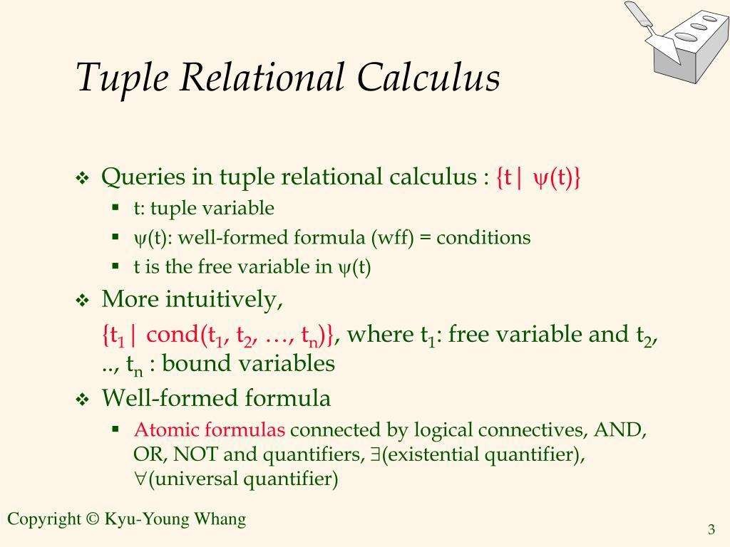
- Airline Reservation System
An Airline Reservation System is a database application used to manage flight bookings, passenger information, and ticket reservations efficiently.

Main Tables
- Passenger: Stores passenger details such as Passenger ID, Name, Contact Number, and Address.
- Flight: Stores flight information including Flight ID, Flight Name, Source, Destination, and Departure Time.
- Booking: Maintains booking details such as Booking ID, Passenger ID, Flight ID, Seat Number, and Booking Date.
- Payment: Stores payment information such as Payment ID, Booking ID, Payment Mode, and Amount.

SQL Queries
The system demonstrates the use of various SQL concepts:
- JOIN Query: Displays passenger names along with their booked flight details.
- Sub-query: Finds passengers who paid more than a specified amount.
- Aggregate Query: Counts the number of bookings for each flight using GROUP BY.
- View: Creates a view showing flight names and total bookings.
- LEFT JOIN: Displays all passengers, including those who have not yet made any bookings.

Advantages
- Reduces manual work. • Ensures data accuracy.
- Supports quick ticket booking and cancellation.
- Provides efficient passenger and flight management.
- Improves security and maintains data consistency.
